Parth Babbar

checking accounts

**Introduction:**

A checking account, available from banks or credit unions, enables easy access to deposited cash for routine financial operations such as payments, withdrawals, and transfers. It is a critical component of personal money management in the United States, maintaining liquidity using methods such as cheques, debit cards, ATMs, and electronic transfers.

**Features of Checking Account:**

1. **Deposits and withdrawals:** Customers can make deposits into their checking accounts using a variety of ways, including direct deposits, transfers, and in-person transactions at bank offices or ATMs. Checks, debit cards, and electronic transfers are all options for withdrawing funds.
2. **Check Writing:** Historically, checking accounts have allowed account holders to write checks to make payments. However, with the introduction of digital banking, cheque writing has become less prevalent than electronic transactions.
3. **Fees and Charges:** Many checking accounts may include costs, such as monthly maintenance fees, overdraft fees, ATM fees (for using ATMs outside the bank's network), and fees for additional services such as chequebook orders.
4. **Interest Rate:** Some checking accounts pay interest on the balance in the account, albeit these rates are often lower than those given by savings accounts.
5. **Online & Mobile Banking:** Most banks provide online and mobile banking services that allow users to manage accounts, pay bills, transfer payments, and deposit checks remotely, providing more ease and accessibility in financial management.  
   A graph of a bar graph

   Description automatically generated with medium confidence

**Types of Checking Account:**

1. **Interest-Bearing Checking Accounts**: Customers can receive interest on their maintained balances with interest-earning accounts, although they often have higher fees than normal accounts.
2. **Student Checking Accounts:** Student accounts are designed exclusively for students, with cheaper fees and simplified regulations to meet their financial needs effectively.
3. **Premium Checking Accounts**: Customers with bigger balances are sometimes eligible for additional incentives like as ATM charge refunds, increased interest rates, and free checks.
4. **Business Checking Accounts:** Designed for commercial transactions, with additional features such as payroll administration.

There are more like senior checking account, reward checking account, etc.

**Statistics:**

1. According to the Federal Deposit Insurance Corporation (FDIC), around 81.5 percent of U.S. households were "fully banked" in 2021.
2. Amount of US citizens in their checking account:  
   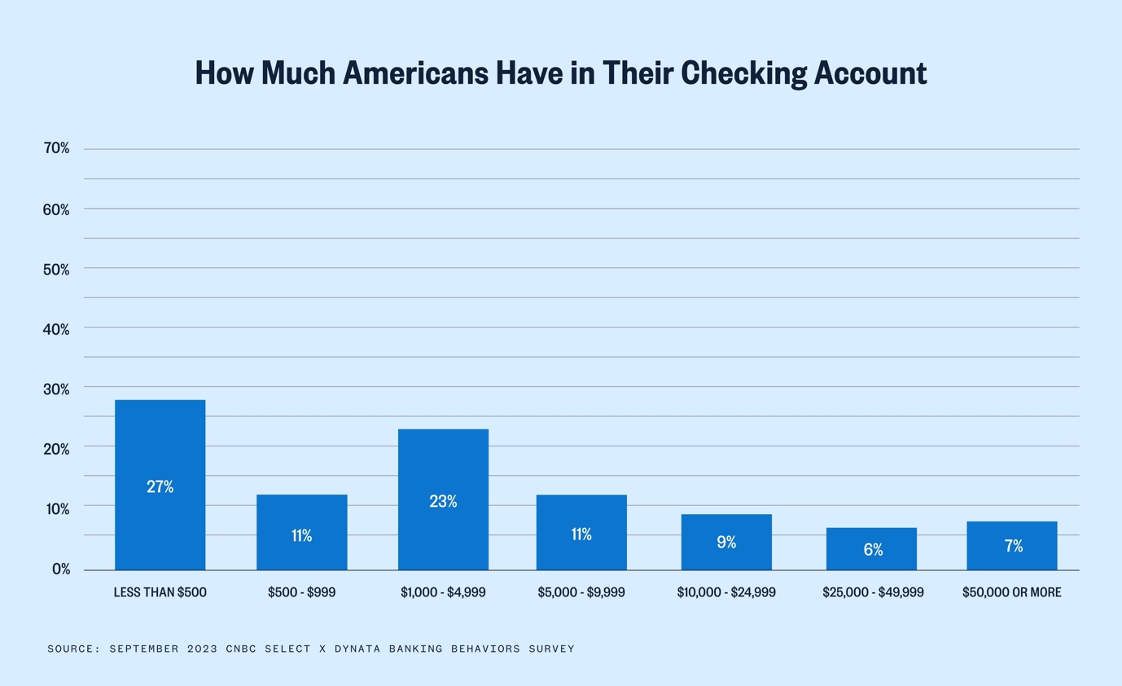
3. As of 2022, 78% of individuals in the United States choose to bank using a mobile app or website. Only 29% of Americans prefer to bank in-person.
4. To retain your account, you must pay a monthly service fee, which is charged by many checking accounts. These costs normally range from $5 to $15 each month. Premium checking accounts with additional banking amenities might cost $25 or more per month.

**Conclusion:**

Checking accounts are an essential component of personal finance in the United States, giving easy access to cash and simplifying everyday financial activities. As technology advances, the landscape of checking accounts evolves, providing users with greater flexibility and ease in managing their money.